**ITCS 2214-002 Program 2.0 – Binary Search Trees Spring 2016**

**Due Tuesday April 5th, 2016 at 11:55PM**

*This assignment is the first portion of the Tree project for this course. The primary goal is to extend the book’s Binary Search Tree implementation with traversal methods and various methods to explore the nodes in the tree, and then visualize the results using Bridges.*

**Overview**

The primary goals of this program are as follows:

1. Understand the book’s Binary Search Tree implementation
2. Add traversal methods and other counting methods
3. Modify the BST class to use Bridges’ BSTElement objects instead of BinNode objects

You need to go through the BST implementation, find every occurrence of a BinNode object and its operations, and replace it with the equivalent BSTElement objects and operations.

The **Driver** will create an instance of the BST class, store a predetermined sequence of integers in it, and visualize the various types of nodes it contains.

**Tasks**

**Copy** the treeLabStarter package from Moodle (this is the package we modified during lab)

**Add** the Bridges JAR file to the build path for this project. Download it from Moodle if necessary

**Documentation** for Bridges classes can be found at the following link:

http://bridgesuncc.github.io/doc/java-api/current/

**BridgesBST –**

* Import *bridges.base.BSTElement* to allow you to use BSTElement objects
* Replace every instance and operation of the BinNode class with a BSTElement object and its equivalent methods
* Add methods to perform each type of traversal: preorder, postorder, inorder
* Add a method to count the number of leaf nodes and assign each a particular color or opacity
* Add a method to count the number of internal nodes and assign each a particular color or opacity
* Add a method to count the number of nodes with two children and assign each a particular color or opacity
* Add a method to determine the height of the tree (the longest path length)

**Driver –**

* Import *bridges.connect.Bridges* to allow you to create a Bridges object
* Initialize a Bridges object with this assignment number, your username, and your API key. (See the Bridges template on Moodle for details)
* The driver will remain essentially the same as the provided skeleton code
* Call Bridges’ setDataStructure method passing in the root of your tree and then call Bridges’ visualize method

**Deliverables –**

The Bridges assignment your program should generate will be something like this: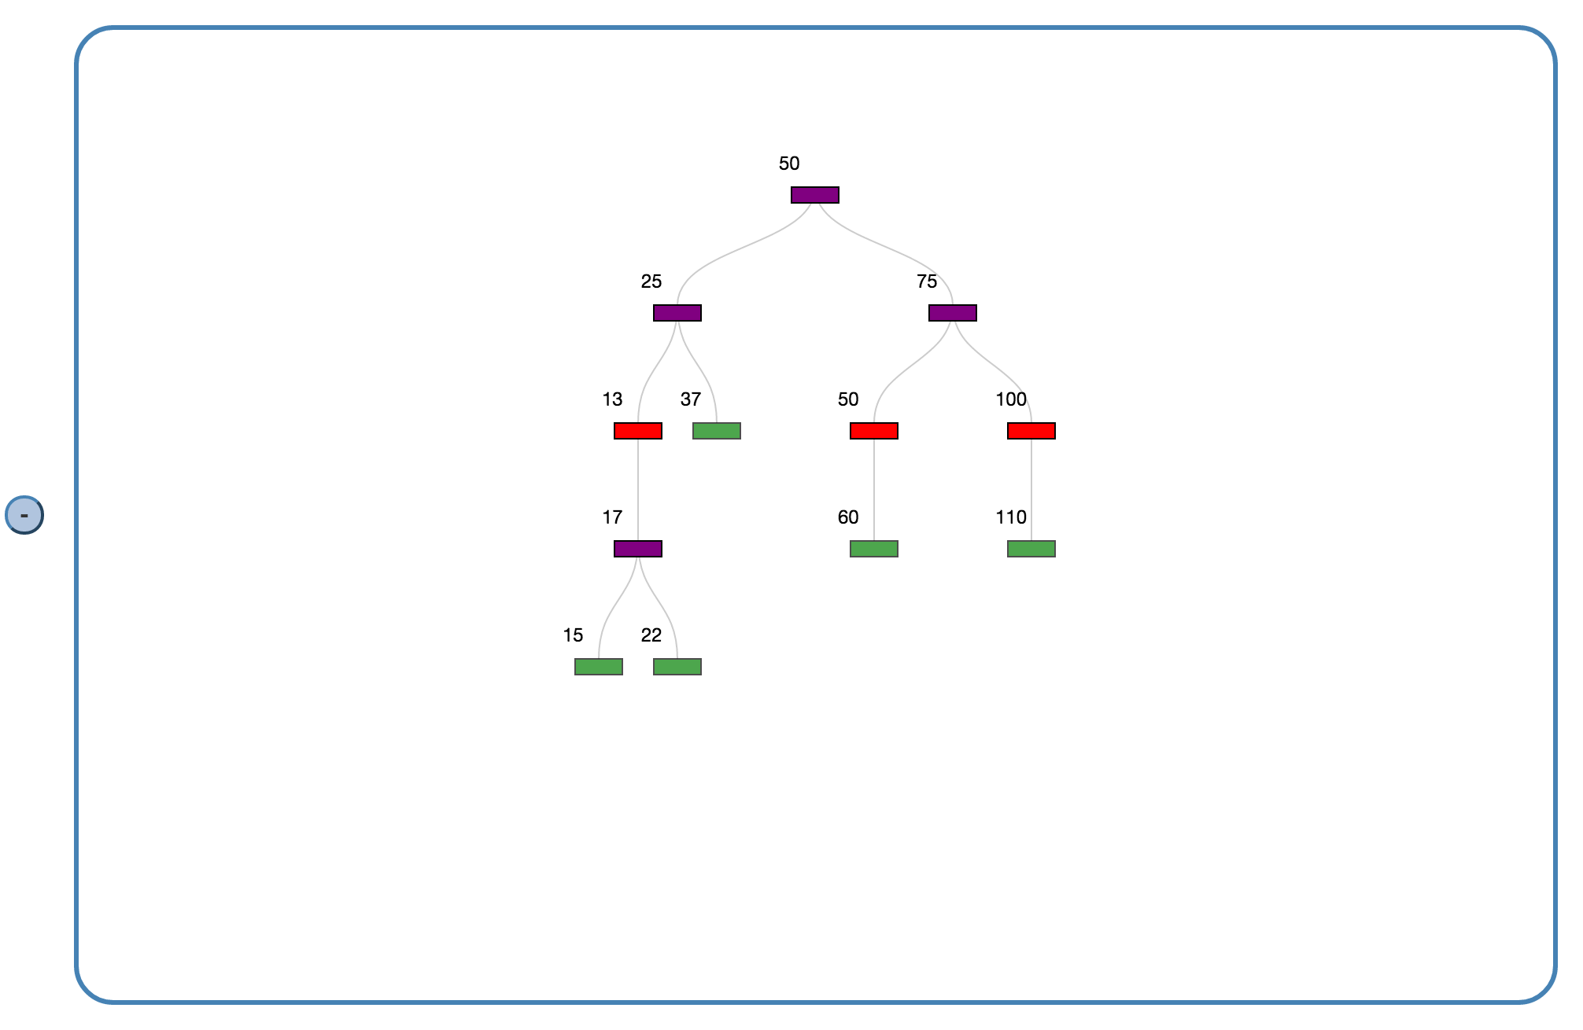

**Scoring Rubric**

**Driver:** 5 points

* Up to 5 points for appropriate documentation and comments

**BridgesBST:** 35 points

* Up to 5 points for appropriate documentation and comments
* Up to 10 points for replacing BinNode objects and methods with BSTElement objects and methods
* Up to 10 points for implementing the traversal methods
* Up to 10 points for implementing the countLeaves, countInternalNodes, countTwoChildNodes, and getMaxPathLength methods

**Visualization:** 10 points

* Up to 10 points for visualizing the leaves, internal nodes, and 2-child nodes with separate colors and/or opacities

**Total points available: 50**

**This will be graded as a programming assignment**

*Late programs will lose 10% of the available points per day.*